VISVESVARAYA TECHNOLOGICAL UNIVERSITY

JNANASANGAMA, BELAGAVI – 590018

An Internship Report

on

ARTIFICIAL INTELLIGENCE AND MACHINE LEARNING

**Submitted in partial fulfillment for the award of degree of**

**Bachelor of Engineering**

**in**

**Artificial Intelligence and Machine Learning**

***Submitted by***

**STEPHEN PEDRU FERNANDES 4SO21AI056**

***Internship Carried Out***

**at**

**OptM Media Solution Pvt. Ltd.**

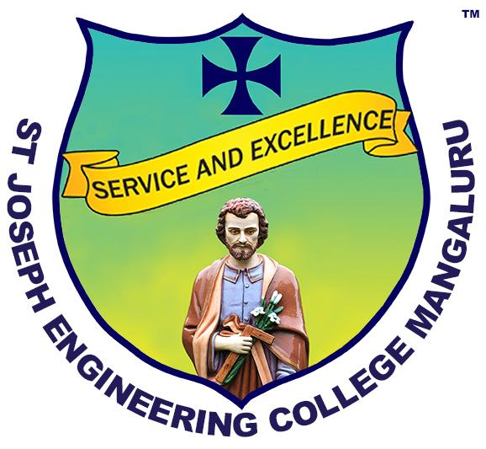

**Internal Guide External Guide**

**Dr. Shreenath Acharya Abhay N**

**<<Designation>> Data Engineer**

**St. Joseph Engineering College OptM Media Solutions Pvt. Ltd.**

**Department of Intelligent Computing & Business Systems**

**St Joseph Engineering College, An Autonomous Institution**

**Mangaluru - 575028**

**2024-25**

VISVESVARAYA TECHNOLOGICAL UNIVERSITY JNANASANGAMA, BELAGAVI – 590018

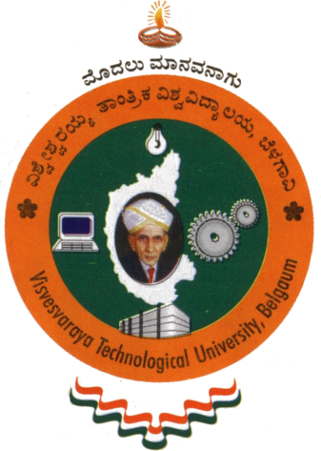

An Internship Report

on

ARTIFICIAL INTELLIGENCE AND MACHINE LEARNING

**Submitted in partial fulfillment of the requirements for the degree**

**Bachelor of Engineering**

**in**

**Artificial Intelligence and Machine Learning**

***Submitted by***

**STEPHEN PEDRU FERNANDES 4SO21AI056**

**Department of Intelligent Computing & Business Systems**

**St Joseph Engineering College, An Autonomous Institution,**

**Mangaluru - 575028**

**2024-25**

**St Joseph Engineering College, Mangaluru – 575 028**

**An Autonomous Institution**

**Department of Intelligent Computing & Business Systems**

#### CERTIFICATE

Certified that the Internship Work titled **Artificial Intelligence and Machine Learning Intern** was carried out by Mr. **Stephen Pedru Fernandes**, bearing USN **4SO21AI056**, a bonafide student of final year B.E. in partial fulfillment for the award of Bachelor of Engineering in Artificial Intelligence and Machine Learning of the Visvesvaraya Technological University, Belagavi, during the year 2024-25. Further, it is certified that all corrections/suggestions indicated during Internal Evaluation have been incorporated in this report.

**------------------------ --------------------------------**

**Dr. Shreenath Acharya Dr Rio D’Souza**

**Internal Guide HOD - ICBS**

**External Viva Voce Examination**

**Name of the Examiners Signature with Date**

**1. -------------------------------------- -------------------------------**

**2. -------------------------------------- -------------------------------**

**DECLARATION**

I, **Stephen Pedru Fernandes,** bearing USN **4SO21AI056**, student of final year B.E. in Artificial Intelligence and Machine Learning, St Joseph Engineering College, Mangaluru, hereby declare that the Internship Work titled **“AIML INTERN”** has been duly executed by me from 04 March 2025 to 04 April 2025, at OptM Media Solutions Pvt. Ltd, Bangalore. Further, the “Tasks Performed” section of this report represents the work done solely by me and does not contain any statements falsely claiming work done by others, as my own.

**Date: 09-05-2025**

**Place: Chennai Student Name**

**Stephen Pedru Fernandes**

**ACKNOWLEDGMENT**

I would like to express my sincere gratitude to all those who supported and guided me throughout my internship journey.

First and foremost, I am deeply thankful to my external guide, Mr. Abhay N at OptM Media Solutions Pvt Ltd., Basavanagudi, Bangalore, for his valuable mentorship, continuous support, and for providing me with the opportunity to work on a meaningful project that enhanced my technical skills and industry understanding.

I extend my heartfelt thanks to my internal guide, Dr. Shreenath Acharya, and coordinator, Ms. Gayana M.N., for their constant encouragement, guidance, and support during the course of this internship.

I would also like to thank our Head of the Department, Dr. Rio Dsouza, for providing a strong academic foundation and facilitating this internship opportunity.

My sincere thanks to the principal of our institution, Dr. Rio Dsouza, for enabling such practical learning experiences that bridge the gap between academics and industry.

I am also grateful to the Assistant Directors and Director for their support and vision in shaping a dynamic learning environment.

Lastly, I would like to thank all the faculty members of the department, my friends, and my family for their moral support, motivation, and continuous encouragement throughout this journey.

**EXECUTIVE SUMMARY**

I carried out my internship as a MERN STACK Intern at OptM Media Solutions Pvt. Ltd. Systems from March 04, 2025, to April 04, 2025. The internship was conducted in an offline format, allowing me to be physically present at the workplace. This provided a more interactive and collaborative learning environment, enabling direct communication with mentors and team members.

OptM Media Solutions Pvt. Ltd., established in 2016 and based in Bangalore, Karnataka, specializes in custom software, web and mobile app development, cloud solutions, and AI/ML systems. The company delivers secure, scalable digital solutions while fostering innovation to enhance business productivity. OptM is committed to driving technological advancements and providing top-notch services to its clients. Their focus on quality and customer satisfaction has positioned them as a trusted partner in the tech industry.

The primary objective of my internship was to gain practical experience and apply academic knowledge in a real-world setting. This experience helped me understand professional work environments, industry practices, and tools commonly used in my field. Internships enhance both technical and soft skills such as communication, teamwork, and problem-solving. They offer valuable exposure to real responsibilities, helping individuals build confidence and clarify career goals. Additionally, internships provide opportunities to network with professionals and strengthen one’s resume for future job prospects. Overall, internships are essential for career development and transitioning smoothly from education to the professional world.

During the internship, I significantly improved my technical capabilities by working on a technical project focused on building a Legal AI Bot to assist with legal requirements. The project utilized the Legal Llama 7B model, React for the frontend, Firebase for user authentication, and Python Fast API for backend services. This hands-on experience allowed me to apply classroom knowledge to real-world scenarios, enhancing my coding skills, logical thinking, and ability to troubleshoot complex issues effectively.

Apart from technical skills, the internship helped me develop essential soft skills that are crucial in any professional setting. I improved my communication and teamwork abilities by participating in regular stand-up meetings, presenting my work, and collaborating with peers and mentors. Working under deadlines taught me effective time management, prioritization, and how to work independently while being accountable for assigned tasks.

STEPHEN PEDRU FERNANDES

**CONTENTS**

|  |  |  |  |
| --- | --- | --- | --- |
| **SL** | **No.** | **Title** | **Page No.** |
| 1 |  | About the Institution | 1 |
|  | 1.1 | Introduction | 1 |
|  | 1.2 | Services offered by the Institution | 1 |
|  | 1.3 | Contact Details | 1 |
| 2 |  | About the department | 2 |
|  | 2.1 | Introduction | 2 |
|  | 2.2 | Roles and Responsibilities | 2 |
| 3 |  | Tasks Performed | 3 |
|  | 3.1 | Weekly Report | 3 |
|  | 3.2 | Project Work (if applicable) | 6 |
|  | 3.3 | Snapshots | 7 |
| 4 |  | Reflection Notes | 14 |
|  | 4.1 | Experience | 14 |
|  | 4.2 | Technical Outcomes | 14 |
|  | 4.3 | Non-technical Outcomes | 15 |
|  |  | References | 16 |